COLD ASHBY VILLAGE HALL
Main Street, Cold Ashby NN6 6EL
Charity number 1024816
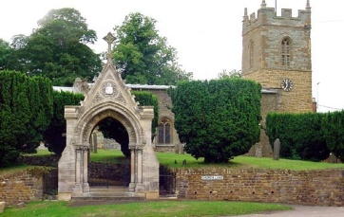
Committee Meeting

Tuesday 22nd May, 2018: 7.30 p.m.

Agenda

- Minutes of meeting on 20th February 2018
- Matters arising:
- Apologies for absence
- Chairman’s report: matters for the committee’s attention
- Finance:
- Monthly accounts February-May
- Activities and usage update:
- Luncheon club (CS)
- Yoga sessions – opening in June
- Water pipe damage
- Electricity issues.
- Door replacement

G Jones, Secretary May 2018

